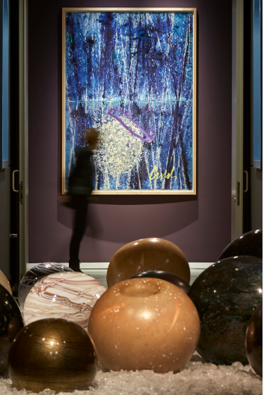 | Dale Chihuly  Basket and Reed Quad Drawing, 2008 and Niijima Floats (detail), 2018  Groninger Museum, Groningen, Netherlands, installed 2018  © Chihuly Studio
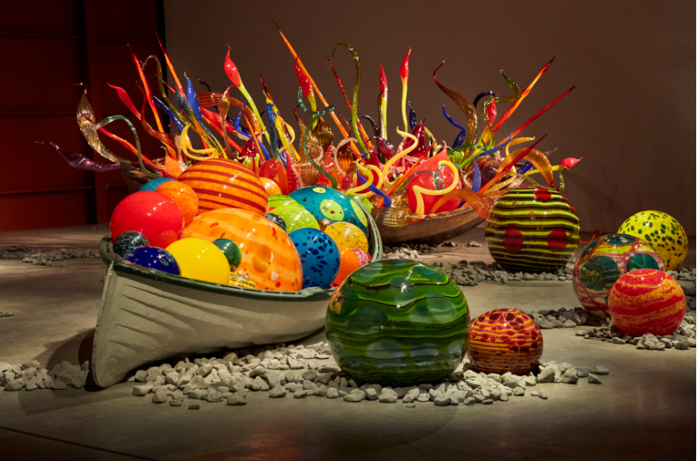 | Dale Chihuly  Float Boat, 2018 and Fiori Boat, 2017  Groninger Museum, Groningen, Netherlands, installed 2018  © Chihuly Studio
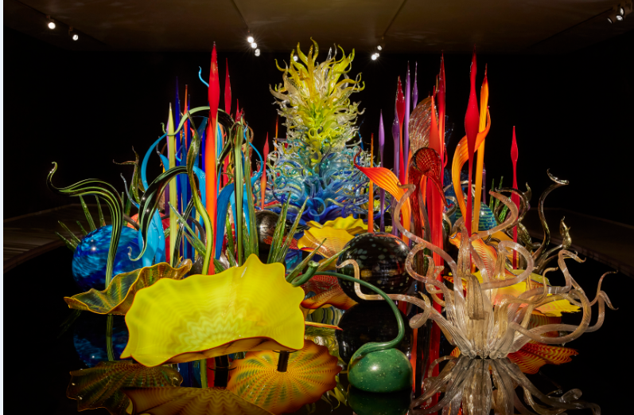 | Dale Chihuly  Mille Fiori, 2018  7 x 35 x 16'  Groninger Museum, Groningen, Netherlands  © Chihuly Studio
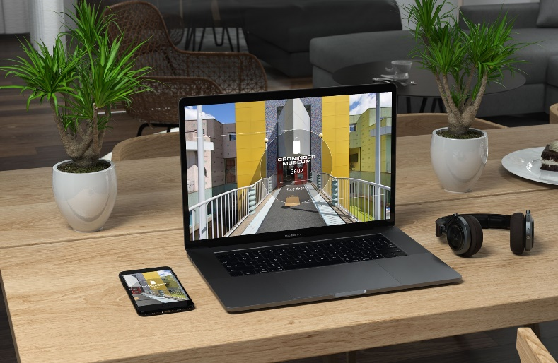 | © Carola de Poel, Panorama-Fotografie

