Photo credits Mondo Mendini – The World of Alessandro Mendini
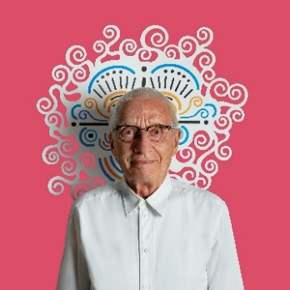 | 1.  Alessandro Mendini  Photo: Carlo Lavatori – Alessandro Mendini Archive
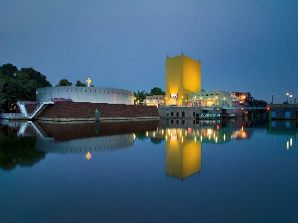 | 2a.  Groninger Museum, Groningen  Photo: Erik en Petra Hesmerg  2014
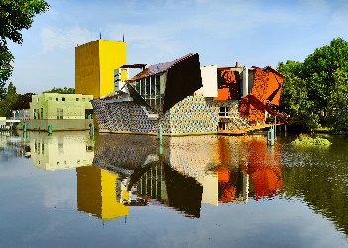 | 2b.  Groninger Museum, Groningen  Photo: Erik en Petra Hesmerg  2014
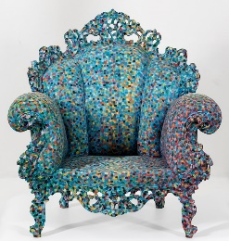 | 3.  Alessandro Mendini, Poltrona di Proust, 1978, collection Groninger Museum.  Photo: Marten de Leeuw
4.
Alessandro Mendini, Anna G., 1994, corkscrew for Alessi.
Photo: Alessi – Alessandro Mendini Archive

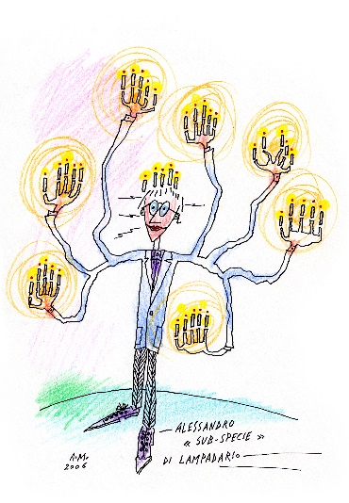 | 5.  Alessandro Mendini, Alessandro as ‘sub-species’ of a Chandelier, 2006, Alessandro Mendini Archive, Milan
6.
Alessandro Mendini, Kandissi Sofa, 1980, collection Groninger Museum.
Photo: Heinz Aebi

7.
Alessandro Mendini, Abissina, 2018, produced by Alessio Sarri, Sesto Fiorentino.
Photo: Marta Sansoni

8.
Alessandro Mendini, Mobili per uomo: Borsa, 1997, collection Fondazione Bisazza, Vicenza.
Photo: Ottavio Tomasini – Fondazione Bisazza Archive

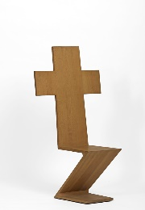 | 9.  Alessandro Mendini, Redesign: Zig Zag Rietveld, 1978, collectie Groninger Museum.  Foto: Marten de Leeuw
10.
Alessandro Mendini, Per Depero, 2010, produced by Galleria Paolo Curti / Annamaria Gambuzzi Milano.
Photo: Alessandro Mendini Archive

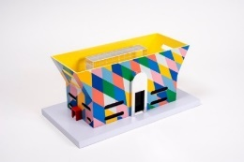 | 11.  Alessandro Mendini and Francesco Mendini, Model for Fursys, Chung Ju, Zuid-Korea, 2018, collection Atelier Mendini, Milan / Abet Laminati, Bra.  Photo: Roberto Gennari Feslikenian
12.
Alessandro Mendini, Damina Llandrò, 2000, collection Alessandro Mendini, Milan.
Photo: Marco Ferrero

13.
Alessandro Mendini, Depero, 2017, produced by Argenteria Pampaloni Firenze.
Photo: Arigo Coppitz
14.
Alessandro Mendini, Lassù, part of the series sculptures in golden brass, 1994-2005, produced by Short Stories.
Photo: Riccardo Bianchi

15.
Alessandro Mendini, Performance Lassù, 1974.
Photo: Alessandro Mendini Archive

16.
Alessandro Mendini, Lassù, 1974, collection Vitra Design Museum, Weil am Rhein.
Photo: Vitra Design Museum - Alessandro Mendini Archive
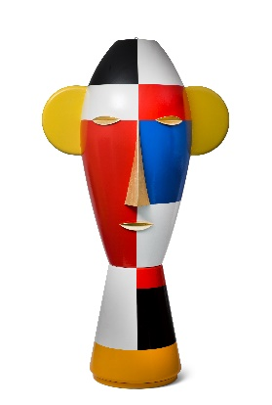 | 17.  Alessandro Mendini, Tête géante, 2002, collection Alessandro Mendini, Milan.  Photo: Groninger Museum / Heinz Aebi
18.
Alessandro Mendini, Giostrina Alessi, 2000, musical carousel, lacquered wood, steel, plastic, Museo Alessi, Crusinallo
Photo: Museo Alessi / Sergio Ricco

19.
Alessandro Mendini and Mara Voce, 100% Make Up, 1992, for Alessi, porcelain, Groninger Museum, Groningen
Photo: Groninger Museum / Marten de Leeuw
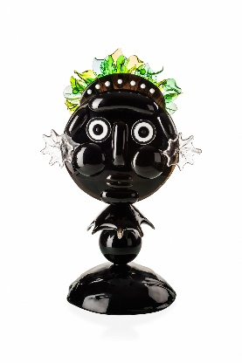 | 20.  Alessandro Mendini, Falstaff, 2015, sculpture for  Venini, glass, Venini, Venice
21.
Alessandro Mendini, Petite cathédrale, 1996-2002,
for Bisazza, miniature building in glass mosaic, wood,
mosaic, glass, plastic, ox-eye window by Mimmo Rotella, Fondation Cartier pour l’art contemporain, Paris
Photo: Fondation Cartier pour l’art contemporain / Luc Bougly

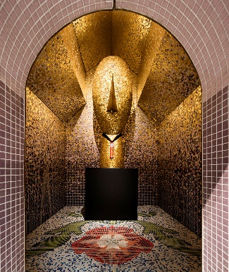 | 22.  Alessandro Mendini, Visage archaïque, 2002, sculpture  for Bisazza, hand-cut gold mosaic, Swarovski crystal,  Fondation Cartier pour l’art contemporain, Paris  Photo: Luc Boegly / Fondation Cartier pour l’art contemporain
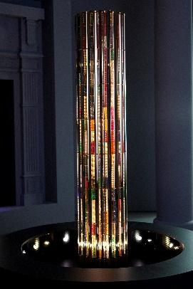 | 23.  Alessandro Mendini, Colonna di Cartier, 2009, gold,  precious stones, pearls, bronze, granite, Cartier, Paris  Photo: Société Cartier / Alessandro Mendini Archive
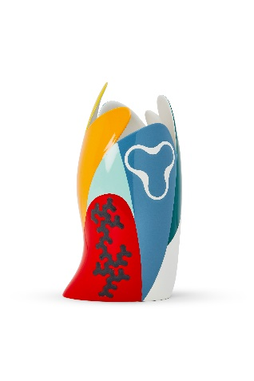 | 24.  Alessandro Mendini, Sinuoso, 2019, ceramic vase for Maison Matisse, Alessandro Mendini Archive, Milan
25.
Henri Matisse, Rocaille armchair and bouquet of tulips, 1943, coloured pencil on paper, private collection, Paris
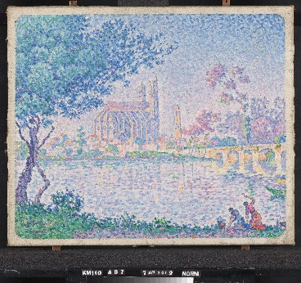 | 26.  Paul Signac, Mantes, 1899/1900, oil on canvas,  Kröller-Müller Museum, Otterlo  Photo: Rik Klein Gotink, Harderwijk
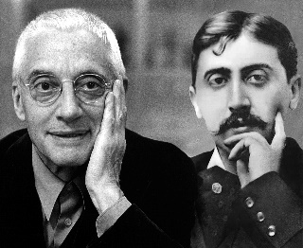 | 27.  Alessandro Mendini and Marcel Proust, 2010, photomontage by Laura Villani; photo of Alessandro Mendini by Gitty Darugar, Alessandro Mendini Archive, Milan
28.
Gio Ponti, Urn, ca. 1935, porcelain, Antonello Collection

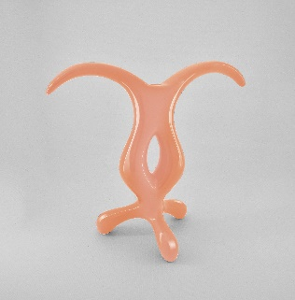 | 29.  Anna Gili, CRO, 2016, resin and lacquered polystyrene, Anna Gili Design Studio, Milan  Photo: Anna Gili Design Studio / Alessandro Mendini Archive
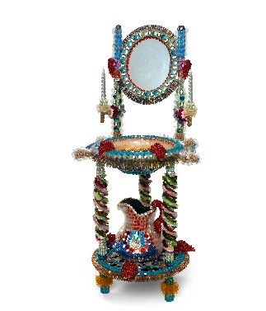 | 30.  Rhonda Zwillinger, Cleanliness is next to Godliness, 1986,  mixed media, Groninger Museum, Groningen  Photo: Groninger Museum / John Stoel

