GM 1 | 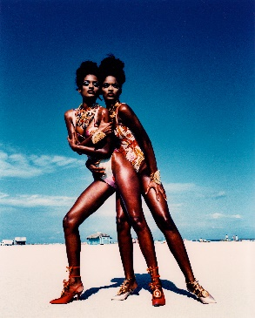 | Campagnebeeld Gianni Versace  Lor & Dor Miami  ©André Rau
 |  | NL | EN | DE
GM 3 |  | David Lees, Gianni Versace en studio medewerkers, 20 september 1986  ©David Lees/ Chronicle Collection/ Getty Images | David Lees, Gianni Versace and studio staff, 20 September 1986  ©David Lees/ Chronicle Collection/ Getty Images | David Lees, Gianni Versace und Ateliermitarbeiter, 20. September 1986  ©David Lees/ Chronicle Collection/ Getty Images
GM 4 |  | David Lees, Gianni Versace, 20 september 1986  ©David Lees/ Chronicle Collection/ Getty Images | David Lees, Gianni Versace, 20 September 1986  ©David Lees/ Chronicle Collection/ Getty Images | David Lees, Gianni Versace, 20. September 1986  ©David Lees/ Chronicle Collection/ Getty Images
GM 5 |  | Dave Benett, “Four Weddings and a Funeral” premiere in Londen, 1994  ©Dave Benett/ Hulton Archive/ Getty Images | Dave Benett, “Four Weddings and a Funeral” premiere in London, 1994  ©Dave Benett/ Hulton Archive/ Getty Images | Dave Benett, “Four Weddings and a Funeral” Premiere in London, 1994  ©Dave Benett/ Hulton Archive/ Getty Images
GM 6 |  | Vittoriano Rastelli, Gianni Versace en zijn modellen, Milan, 1 maart 1991  ©Vittoriano Rastelli/ Corbis Historical/ Getty Images | Vittoriano Rastelli, Gianni Versace and his models, Milan, 1 March 1991  ©Vittoriano Rastelli/ Corbis Historical/ Getty Images | Vittoriano Rastelli, Gianni Versace und seine Models, Mailand, 1. März 1991  ©Vittoriano Rastelli/ Corbis Historical/ Getty Images
GM 8 | 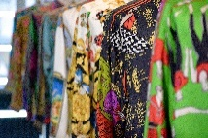 | Gianni Versace  Silk Shirt Army  ©Karl von der Ahé
GM 11 | 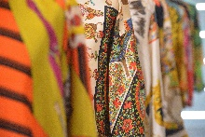 | Gianni Versace  Silk Shirt Army  ©Karl von der Ahé
GM 13 | 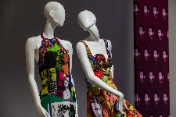 | Gianni Versace  Pop Art (Vogue Dress & Marilyn Monroe/James Dean Dress)  ©Dirk Patschkowski
GM 14 | 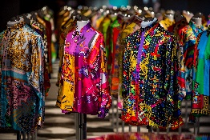 | Gianni Versace  Silk Shirt Army  ©Dirk Patschkowski
GM 15 | 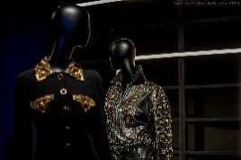 | Gianni Versace  Magna Graecia  ©Dirk Patschkowski
GM 17 | 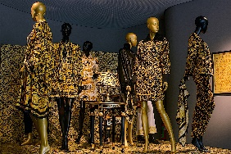 | Gianni Versace  ©Dirk Patschkowski
GM 18 | 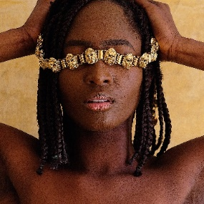 | ©Dreamrealizer
GM 19 | 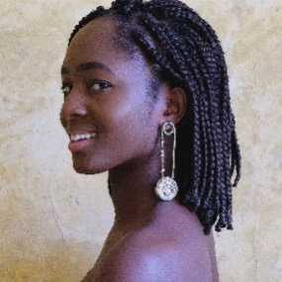 | ©Dreamrealizer
GM 21 | 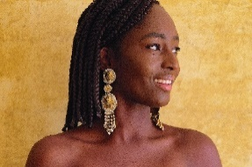 | ©Dreamrealizer
GM 22 | 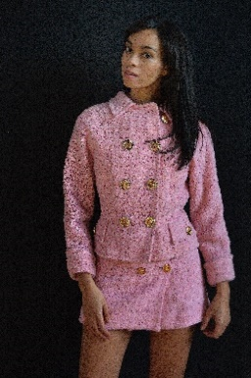 | ©Dreamrealizer
GM 24 | 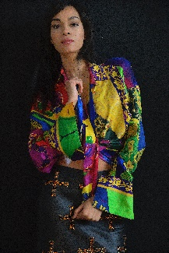 | ©Dreamrealizer
GM 25 | 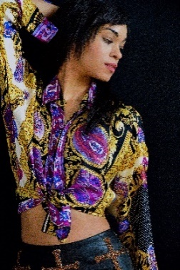 | ©Dreamrealizer
GM 26 | 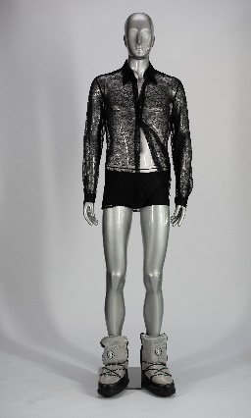 | Gianni Versace, ensemble, herfst/winter 1996-97, nylon-zijde blend, nylon-elastaan blend. Collectie Doriana & Salvatore Alderuccio.  ©Ruilof Images/Joop van Putten. Met dank aan WBOOKS.
GM 27 | 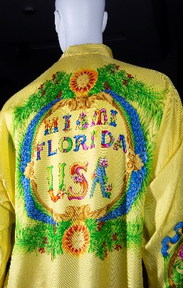 | Gianni Versace, hemd, lente/zomer 1993, zijde. Collectie Antonio Caravano.  ©Ruilof Images/Joop van Putten. Met dank aan WBOOKS.
GM 28  GM 29  GM 30  GM 31  GM 32  GM 33  GM 34 | 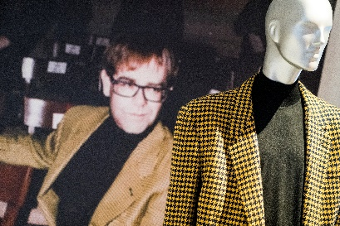 | ©Siese Veenstra
GM 35  GM 36 | 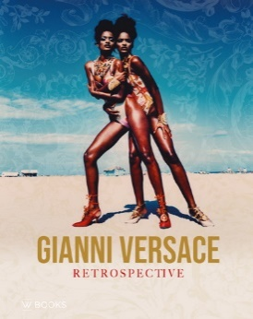 | ©WBOOKS

