Foto | Bijschrift
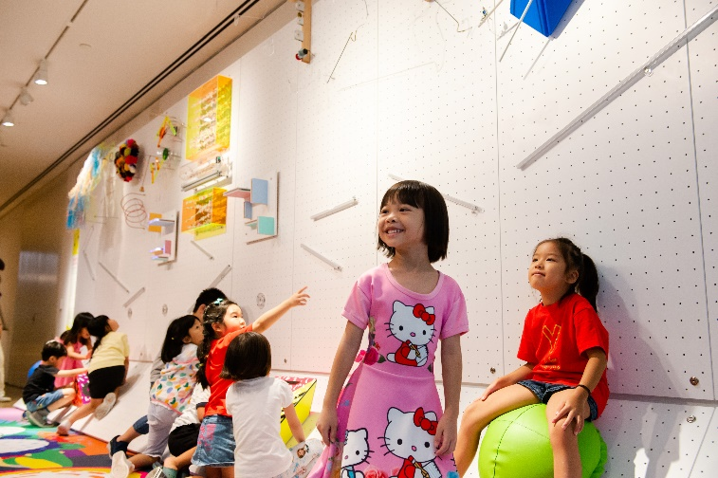 | The Oort Cloud and the Blue Mountain  Foto: The National Gallery Singapore
Kenangan Kunang-Kunang

Foto: The National Gallery Singapore

