Bijschriften The Rolling Stones – Unzipped

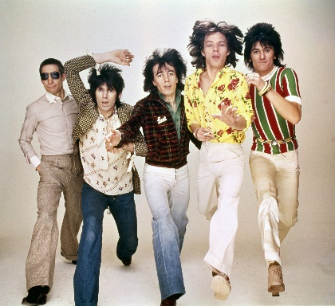 | The Rolling Stones  Foto: The Rolling Stones archive
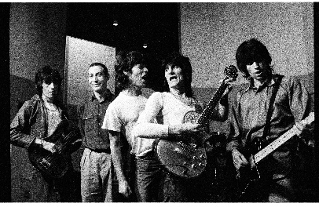 | The Rolling Stones  Foto: Helmut Newton
The Rolling Stones
Foto: Claude Gassian

The Rolling Stones
Foto: Claude Gassian

Charlie Watts
1965 Ludwig Sky Blue Pearl Keystone Badge
Collection Rolling Stones Archive

Keith Richards
Dan Armstrong 6 String, c. 1970
Collection Rolling Stones Archive

Keith Richards
Silk Shirt worn on Bridges to Babylon Tour, 1997-1998
Designed by Joanie Char

Set List London 15 May 2014
Ronnie Wood
Paint on canvas
Collection Rolling Stones Archive

