Credits The Art of Hipgnosis
Image 1 – 14 | 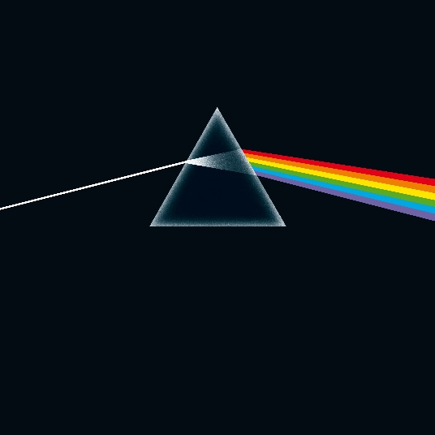 | ©Hipgnosis
Image 15 | 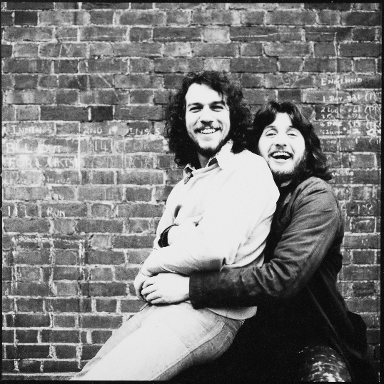 | Aubrey Powell and Storm Thorgerson, 1968  ©Rupert Truman
Image 16 - 28 | 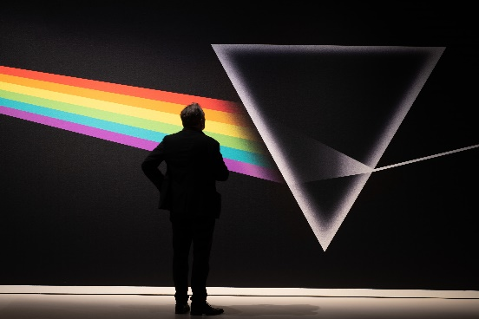 | ©Arjan Verschoor
Image 29 - 34 | 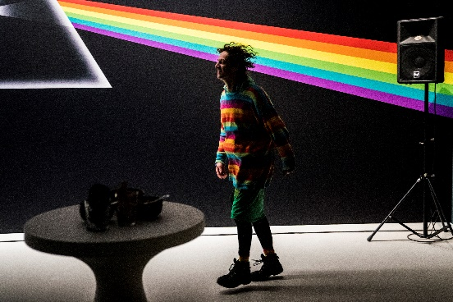 | ©Siese Veenstra
Image 35 |  | ©Hipgnosis
Image 36 | 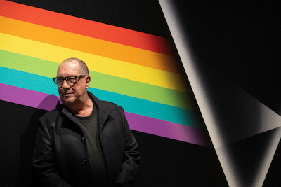 | ©Jeroen Neef

