The Rolling Stones – Unzipped
Bijschriften/Credits/Bildunterschriften

 | Keith Richards  Gibson Les Paul Custom, 1957
Diary Keith Richards, 1963.
©Keith Richards Archive
Mick Jagger, Omega T-Shirt and Cape, 1969.
Cape Designed by Ossie Clark
©Collection Rolling Stones Archive
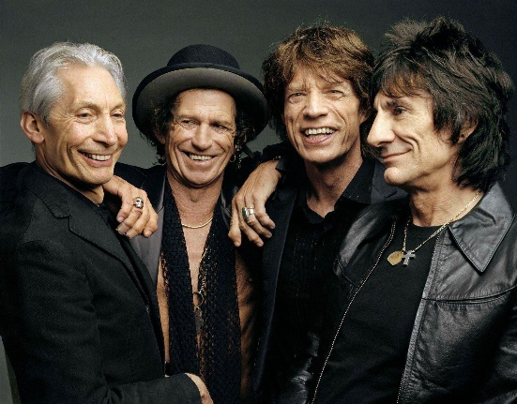 | The Rolling Stones  ©The Rolling Stones archive
 | The Rolling Stones  ©Steve Klein
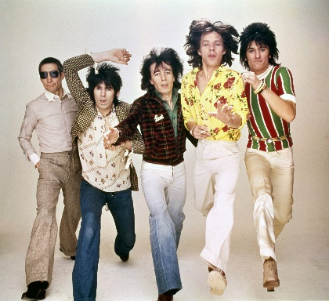 | The Rolling Stones  ©The Rolling Stones archive
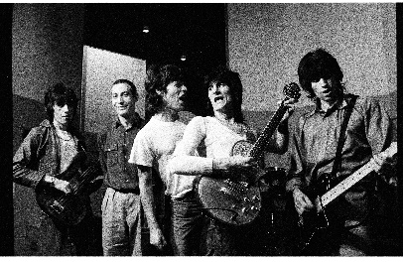 | The Rolling Stones  ©Helmut Newton
 | The Rolling Stones  ©Claude Gassian
 | The Rolling Stones  ©Claude Gassian
Charlie Watts
1965 Ludwig Sky Blue Pearl Keystone Badge
Collection Rolling Stones Archive

Keith Richards
Dan Armstrong 6 String, c. 1970
Collection Rolling Stones Archive

Keith Richards
Silk Shirt worn on Bridges to Babylon Tour, 1997-1998
Designed by Joanie Char

Set List London 15 May 2014
Ronnie Wood
Paint on canvas
Collection Rolling Stones Archive

 | The Rolling Stones – Unzipped  Groninger Museum, 2020-2021  ©Peter Tahl
 | The Rolling Stones – Unzipped  Groninger Museum, 2020-2021  ©Peter Tahl
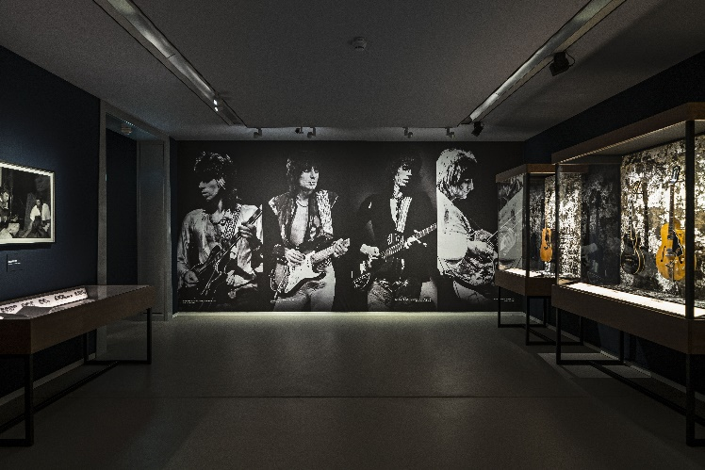 | The Rolling Stones – Unzipped  Groninger Museum, 2020-2021  ©Peter Tahl
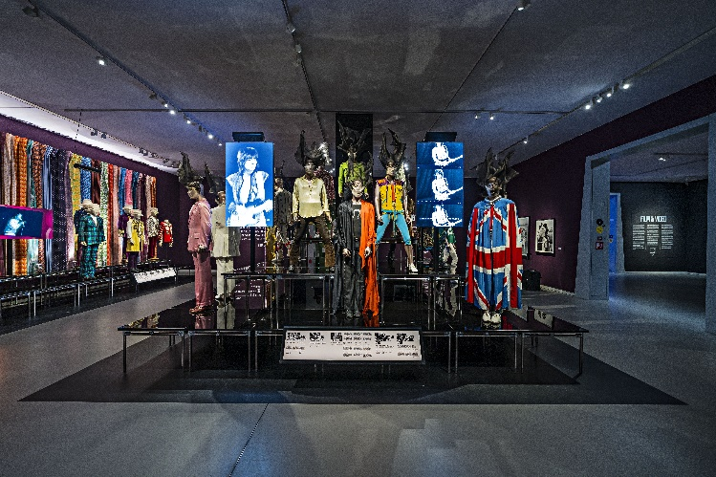 | The Rolling Stones – Unzipped  Groninger Museum, 2020-2021  ©Peter Tahl
 | The Rolling Stones – Unzipped  Groninger Museum, 2020-2021  ©Peter Tahl
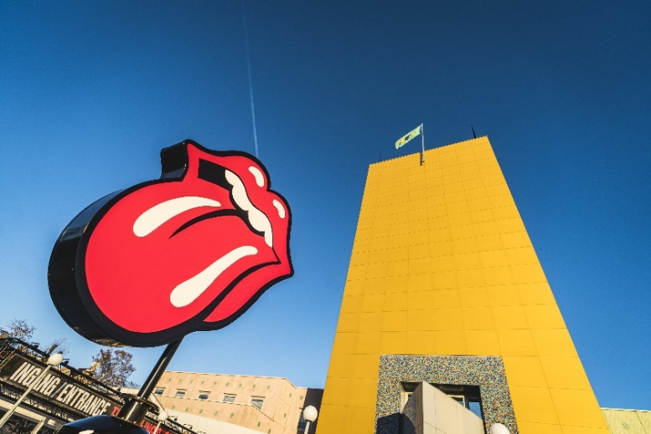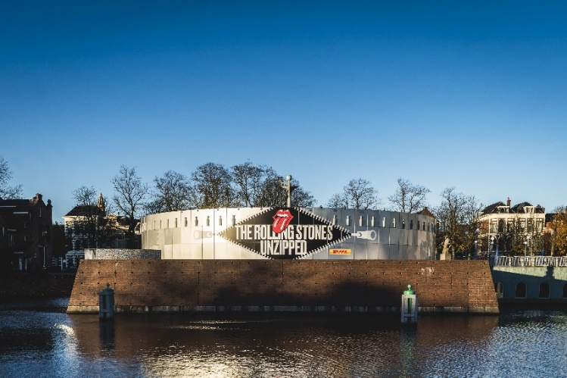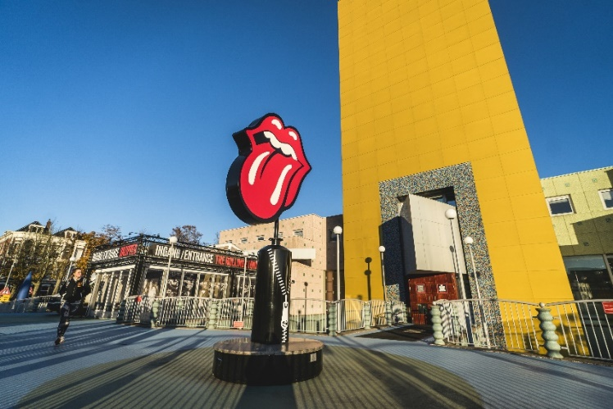 | The Rolling Stones – Unzipped  Groninger Museum, 2020-2021  ©Siese Veenstra

