Credits The Rolling Stones
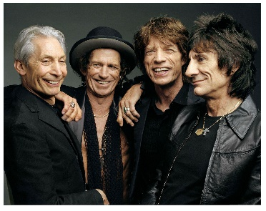 | 1.  The Rolling Stones  Photo: The Rolling Stones Archive
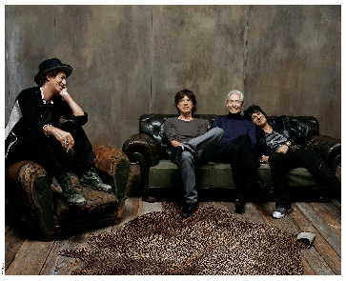 | 2.  The Rolling Stones  Photo: Steve Klein
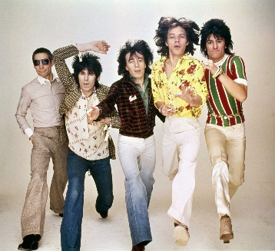 | 3.  The Rolling Stones  Photo: The Rolling Stones Archive
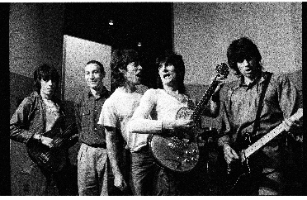 | 4.  The Rolling Stones  Photo: Helmut Newton
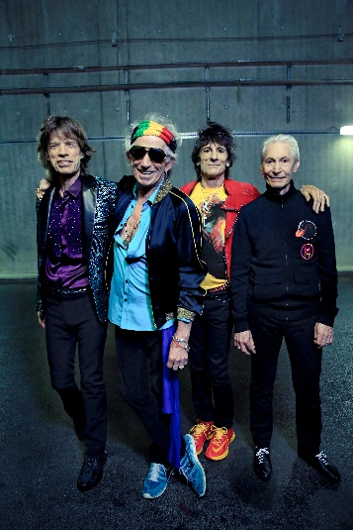 | 5.  The Rolling Stones  Photo: Claude Gassian
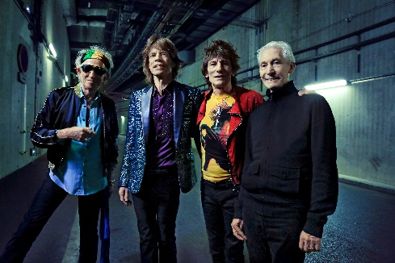 | 6.  The Rolling Stones  Photo: Claude Gassian

